Quick Installation Guide
Wireless LAN Card

Package Contents
- One Wireless network adapter
- One Software CD (includes user guide and driver)
Product Features
- Supports soft AP feature
- Detects wireless network and adjusts transmitting rate automatically
- Provides two working modes: Infrastructure and Ad-Hoc
- Supports WEP data encryption and WPA-PSK/WPA2-PSK encryption methods
- Supports WPS (Wi-Fi Protected Setup) encryption to secure your wireless network
- Complies with Windows 8/7/XP/ 2000/Vista, Linux, MAC OS, etc.
Hardware Installation
Please insert the Wireless USB Adapter into the USB port of your computer.
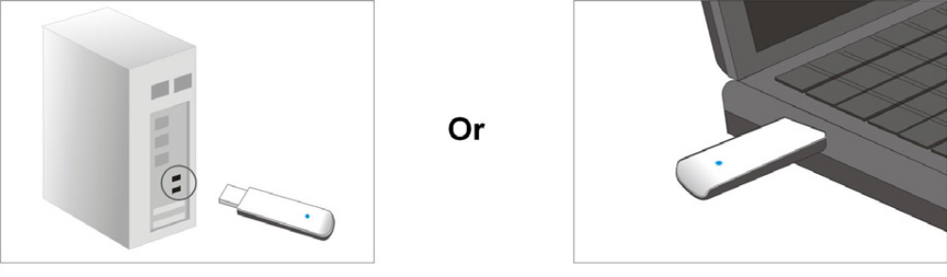

Soft Installation
- When The “Found New Hardware Wizard” system dialogue pops up, we recommend that you select” Cancel” and use the included Setup Wizard software CD for fast installation.
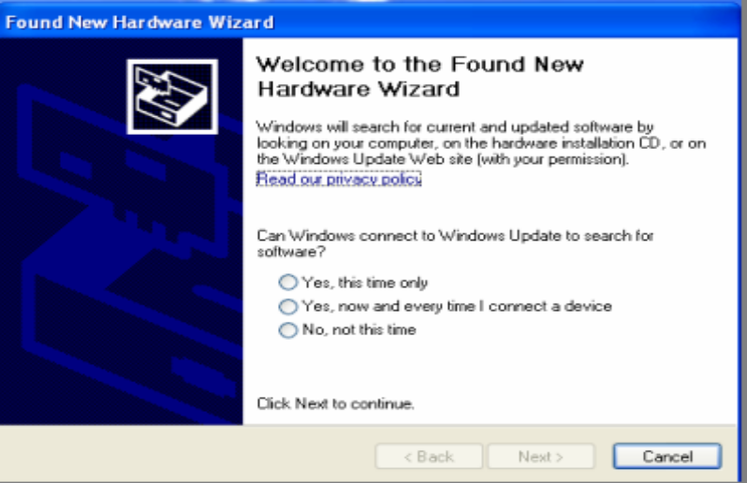
- Insert the installation CD to your CD-ROM and run setup program. “Ralink Wireless LAN – InstallShield Wizard” will appear on your screen, select “I accept the terms of the license agreement” then click “Next”.
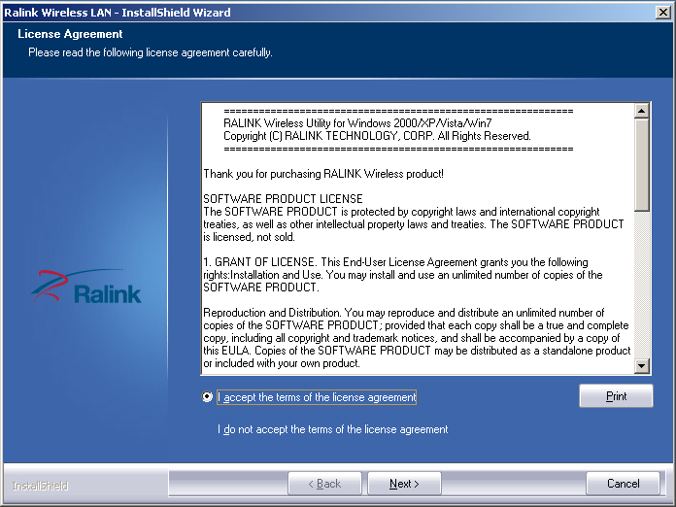
- Choose to install the driver and Ralink WLAN Utility, and Next.
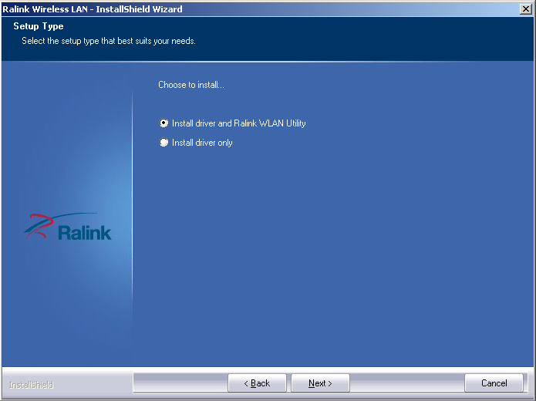

- Choose Ralink Configuration Tool, and Next.
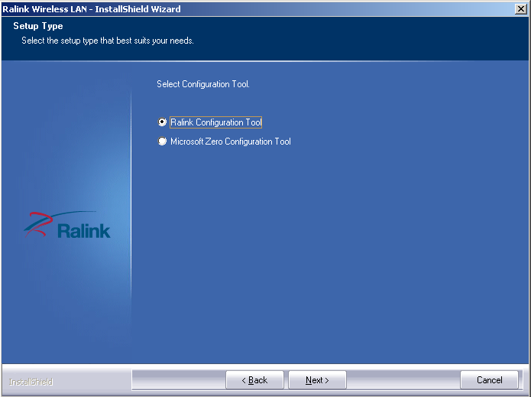

- Click Install to start installation.
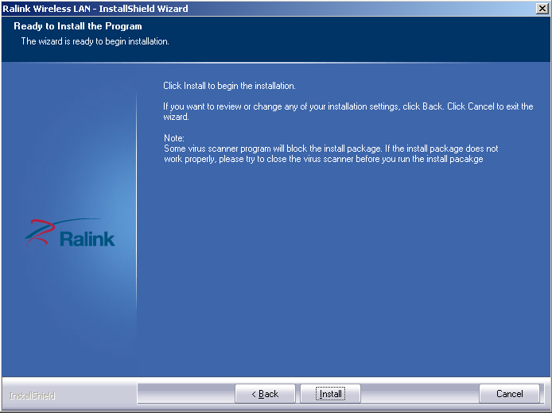

- Wait to Setup.
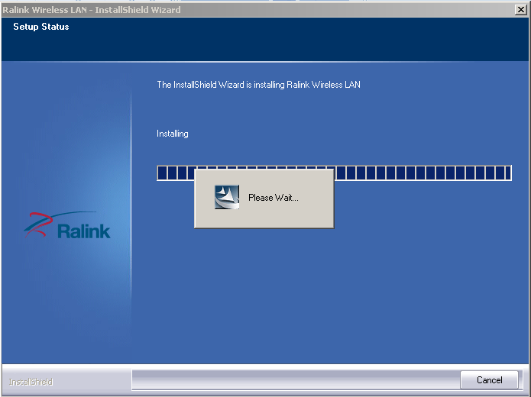

- Click Finish to complete, and the wireless card driver has setup on your computer, it can identify your USB LAN card now.
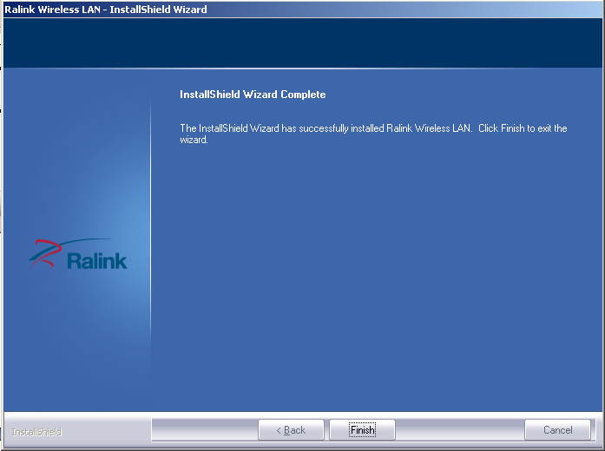

- When it appear like this,Double click icon,and then appear as follow.
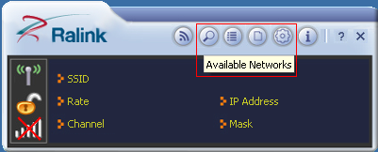

- Click and ,then you can see as follow.
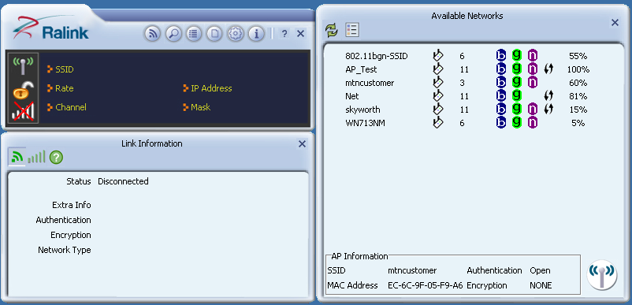
- Select a SSID you want to connect , click to connect.
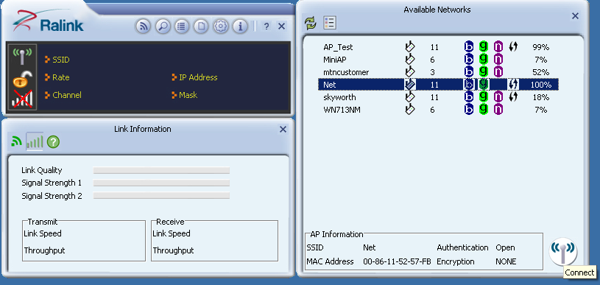
- Connect succeful.
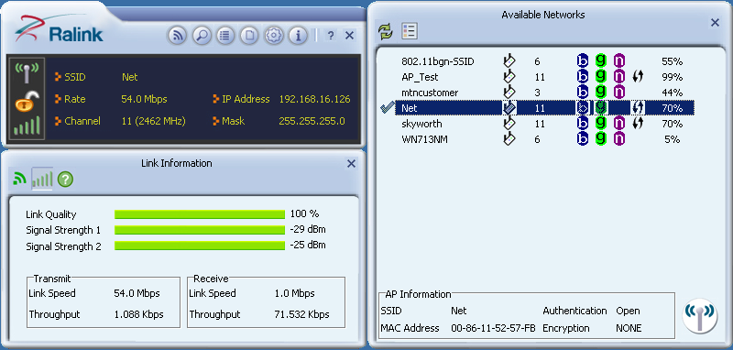
- If encryption,click and will appear as follow,clickto next;
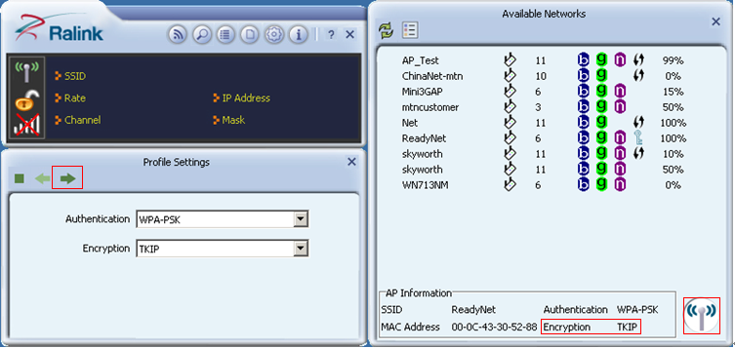
- Enter the password clickto next;
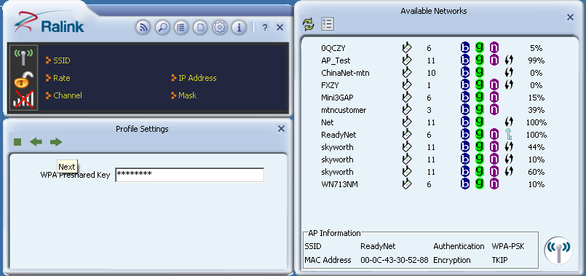
- Connect succeful,if you want to view Throughput,click
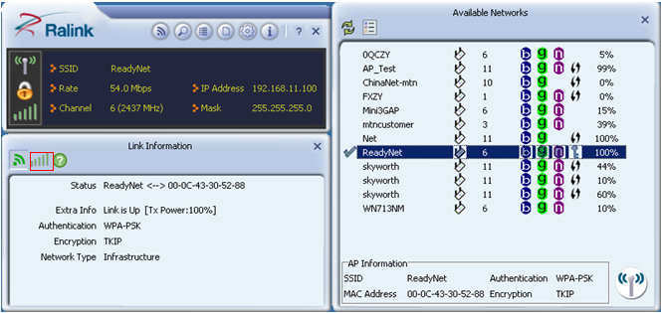
- Then, that’s OK.


